

|  |
| --- |
| Business Template |
| **Logo / Image** |

Contents

1 Business Description 3

1.1 Business background 3

1.2 Problems. Current Situation 3

1.3 The benefits of implementing a database. Project Vision 3

2 Model description 3

2.1 Definitions & Acronyms 3

2.2 Logical Scheme 3

2.3 Objects 3

# Business Description

## Business background

## Problems. Current Situation

## the Benefits of implementing a database. Project Vision

# Model description

A rough sketch of how a logical scheme would look.

## 2.1 Definitions & Acronyms

The following terms and acronyms are used throughout this document:  
- PK: Primary Key  
- FK: Foreign Key  
- bigint: A data type used for storing large integer values  
- text: A data type used for storing long text strings  
- boolean: A data type used for storing binary values (True/False)

## 2.2 Logical Scheme

The logical scheme representing the database structure is shown below:

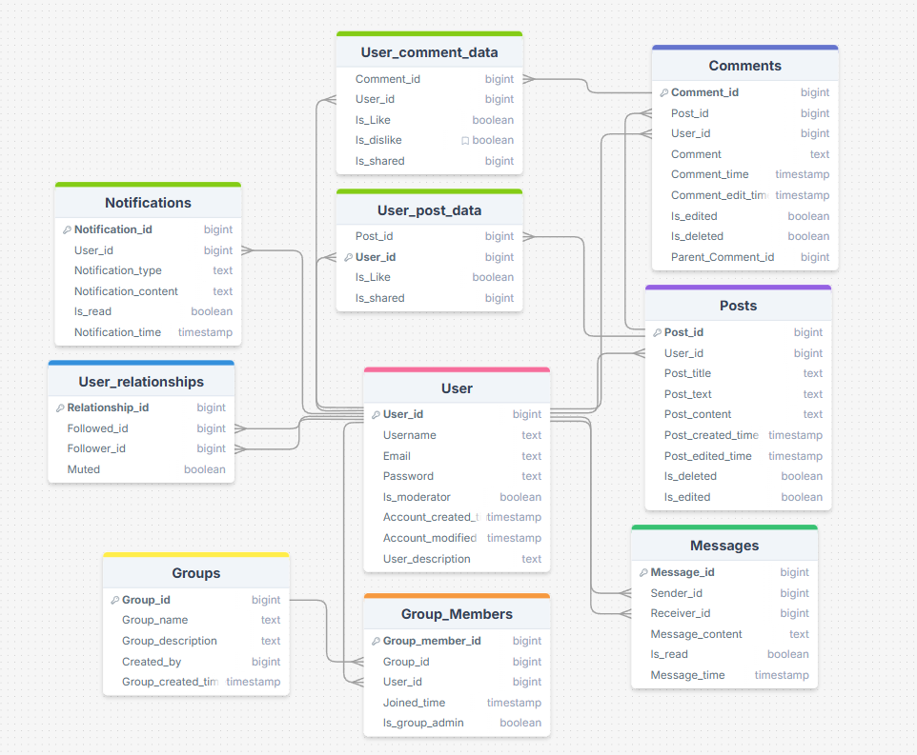

## 2.3 Objects

The following are the tables and fields included in the database:

### Table: User_comment_data

|  |  |  |  |
| --- | --- | --- | --- |
| Field Name | Data Type | Constraints | Description |
| Comment_id | bigint |  | Primary Key |
| User_id | bigint |  | Foreign Key to User |
| Is_Like | boolean |  | Indicates if the comment is liked |
| Is_dislike | boolean |  | Indicates if the comment is disliked |
| Is_shared | boolean |  | Indicates if the comment is shared |

### Table: Comments

|  |  |  |  |
| --- | --- | --- | --- |
| Field Name | Data Type | Constrainst | Description |
| Comment_id | bigint | Not Null (automatically generated) | Primary Key |
| Post_id | bigint |  | Foreign Key to Posts |
| User_id | bigint |  | Foreign Key to User |
| Comment | text(100( |  | Text of the comment |
| Comment_time | timestamp | Not Null (automatically generated) | Time when the comment was made |
| Is_edited | boolean |  | Indicates if the comment is edited |
| Is_deleted | boolean |  | Indicates if the comment is deleted |
| Parent_Comment_id | bigint |  | Parent comment id |

### Table: Posts

|  |  |  |  |
| --- | --- | --- | --- |
| Field Name | Data Type | Constrainst | Description |
| Post_id | bigint | Not Null (automatically generated) | Primary Key |
| User_id | bigint |  | Foreign Key to User |
| Post_title | text(100) | Not Null | Title of the post |
| Post_text | text(200) | Not Null | Main text content of the post |
| Post_content | text(100) |  | Content or body of the post |
| Post_created_time | timestamp | Not Null (automatically generated) | Creation time of the post |
| Is_deleted | boolean |  | Indicates if the post is deleted |
| Is_edited | boolean |  | Indicates if the post is edited |

### Table: User

|  |  |  |  |
| --- | --- | --- | --- |
| Field Name | Data Type | Constrainst | Description |
| User_id | bigint | Not Null (automatically generated) | Primary Key |
| Username | text(50) | Not Null Unique | User's username |
| Email | text(50) | Not Null Unique | User's email address |
| Password | text(100) | Not Null | User's password |
| Is_moderator | boolean |  | Indicates if the user is a moderator |
| Account_created_time | timestamp | Not Null (automatically generated) | Time when the account was created |

### Table: User_relationships

|  |  |  |  |
| --- | --- | --- | --- |
| Field Name | Data Type | Constrainst | Description |
| Relationship_id | bigint |  | Primary Key |
| Followed_id | bigint |  | User being followed |
| Follower_id | bigint |  | User following another user |
| Follow | boolean |  | Indicates if the relationship is a follow |
| Muted | boolean |  | Indicates if the relationship is muted |

### Table: User_post_data

|  |  |  |  |
| --- | --- | --- | --- |
| Field Name | Data Type | Constrainst | Description |
| Post_id | bigint |  | Foreign Key to Posts |
| User_id | bigint |  | Foreign Key to User |
| Is_Like | boolean |  | Optional Like = True Dislike = False |
| Is_shared | boolean |  | Indicates if the post is shared |

### Table: Groups

|  |  |  |  |
| --- | --- | --- | --- |
| Field Name | Data Type | Constrainst | Description |
| Group_id | bigint | Not Null (automatically generated) | Primary Key |
| Group_name | text(100) | Not Null | Name of the group |
| Group_description | text(200) |  | Description of the group |
| Created_by | bigint | Not Null | User ID of the group creator |
| Group_created_time | timestamp | Not Null (automatically generated) | Timestamp for when the group was created |

### Table: Group_member_id

|  |  |  |  |
| --- | --- | --- | --- |
| Field Name | Data Type | Constrainst | Description |
| Group_member_id | bigint | Not Null (automatically generated) | Primary Key |
| Group_id | bigint |  | Foreign Key to Groups |
| User_id | bigint |  | Foreign Key to User |
| Joined_time | timestamp | Not Null (automatically generated) | Timestamp for when the user joins group |
| Is_group_admin | boolean |  | Indicates if the user is group admin |

### Table: Messages

|  |  |  |  |
| --- | --- | --- | --- |
| Field Name | Data Type | Constrainst | Description |
| Message_id | bigint | Not Null (automatically generated) | Primary Key |
| Sender_id | bigint | Not Null | Foreign Key to User |
| Receiver_id | bigint | Not Null | Foreign Key to User |
| Message_content | timestamp | Not Null | User sent message |
| Is_read | boolean |  | Indicate if message has been read |
| Message_time | timestamp | Not Null (automatically generated) | Timestamp for when the message was sent |

### Table: Notifications

|  |  |  |  |
| --- | --- | --- | --- |
| Field Name | Data Type | Constrainst | Description |
| Notification_id | bigint | Not Null (automatically generated) | Primary Key |
| User_id | bigint | Not Null | Foreign Key to User |
| Notification_type | text | Not Null | The type of notification (message, event, ect) |
| Notification_content | timestamp | Not Null | Text in the notification |
| Is_read | boolean |  | Indicate if message has been read |
| Notification_time | timestamp | Not Null (automatically generated) | Timestamp for when the notification was sent |

Relationships Descriptions:  
---------------------------

* **User to Comments**: One-to-many relationship. A user can make many comments, but each comment is made by one user.
* **User to Posts**: One-to-many relationship. A user can create multiple posts, but each post is created by one user.
* **Posts to Comments**: One-to-many relationship. A post can have many comments, but each comment belongs to one post.
* **User to User_relationships**: Many-to-many relationship. A user can follow many other users, and each user can have many followers. The User_relationships table tracks the follow relationships.
* **User to User_comment_data**: Many-to-many relationship. A user can interact (like, dislike, share) with many comments, and each comment can have multiple user interactions.
* **User to User_post_data**: Many-to-many relationship. A user can interact (like, dislike, share) with many posts, and each post can have multiple user interactions.
* **Groups to Group_Members**: One-to-many relationship. A group can have many members, but each member belongs to one group.
* **User to Groups**: One-to-many relationship. A user can create many groups, but each group is created by one user.
* **Groups to User**: Many-to-many relationship (via Group_Members). A user can be a member of many groups, and each group can have many members.
* **User to Messages**: One-to-many relationship. A user can send many messages, but each message is sent by one user (Sender_id).
* **User to Messages (Receiver)**: One-to-many relationship. A user can receive many messages, but each message is received by one user (Receiver_id).
* **User to notification**: One-to-many relationship. A user can receive many notifications, but each notification is received by one user (User_id).